Notice of Annual General Meeting

Collaborative Radically Integrated Performers Society Edmonton (CRIPSiE) -5017604025

Tuesday, May 23, 2019 @ 7:00 pm
Location: Studio A, Fringe Theatre Adventures Society,
10330 - 84 Avenue, Edmonton, Alberta

NOTE: If you are unable to attend please ensure that you fill out the attached proxy form and provide to another CRIPSiE member or submit to the Board two days prior to the AGM by email to wencomar@gmail.com.

AGENDA

- Call meeting to order
- Chairperson takes the chair
- Establish Quorum and certify the proxies
- Proof of Notice of Meeting
- Adopt the agenda
6. Adopt the minutes of the last Annual General Meeting 2018
7. The President’s report
8. Review the yearend financial statements
9. Appoint the auditors
10. Artistic Directors’ Report
11. Elect Members of the Board for 2019/2020
12. New Business
13. Adjournment

CRIPSiE Board Members for 2018/2019
Ainsley Hillyard – Chair
Jasleen Sekhon – Treasurer
Wendy Marusin - Secretary
Krista Lin – Past Treasurer and board member at large

2019-2020
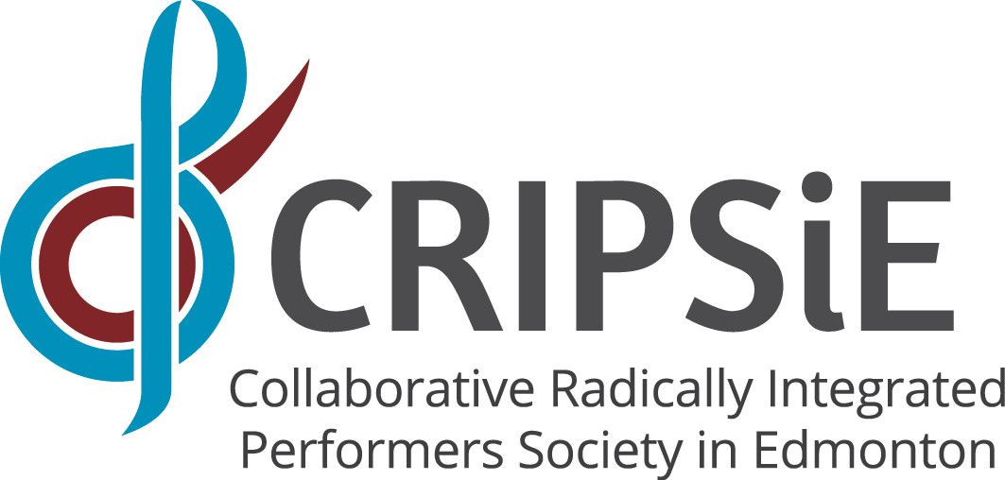
Membership Application
Membership is Free!

Date: ________________________

Name: ______________________________________________________

Email: ______________________________________________________

Phone Number: ______________________________________________

Address, City and Postal Code: __________________________________

____________________________________________________________

____________________________________________________________

Email Preferences (Circle one):

- Yes, I agree to have CRIPSiE email me up to six times a year with news of upcoming CRIPSiE events. (Please circle).

- No, please email me only about General and Special Meetings of the Society.

Would you like to be on our volunteer contact list?

- Yes

- No
Annual General Meeting
Collaborative Radically Integrated Performers Society Edmonton (CRIPSiE)

PROXY

The Members: Collaborative Radically Integrated Performers Society Edmonton (CRIPSiE) – 5017604025

I, _________________________________________________________________

am a registered member of Collaborative Radically Integrated Performers Society Edmonton (CRIPSiE) – 5017604025.

I do hereby appoint __________________________________________________

To be my proxy for all purposes associated with the business to be conducted at the Annual General Meeting (AGM) of the members of Collaborative Radically Integrated Performers Society Edmonton (CRIPSiE) – 5017604025.

Being held on the 23 day of May 2019 at Studio A, Fringe Theatre Adventures Society, 10330 - 84 Avenue, Edmonton, Alberta, or at any adjournment of the same.

__________________________________ _________________________
Signature of Member Date

